**Aim –**

1. What goes into integrating SonarCloud.
2. How to use SonaCloud.

**What goes into integrating SonarCloud.**

* SonarCloud is the cloud version of the SonarQube tool.
* This service can be used to improve the quality of your code.
* You can use the tool free of cost for the public projects that you host on Azure DevOps services.

Steps-

1. First register with SonarCloud using your Azure Devops account.

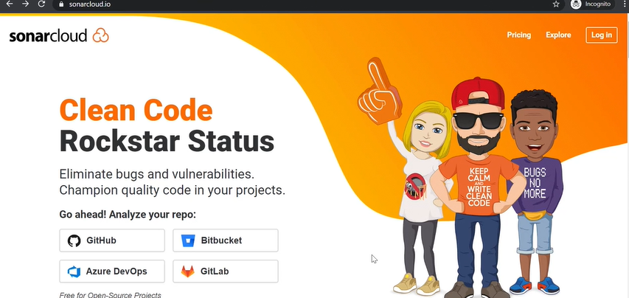

Once login you will get screen like this.

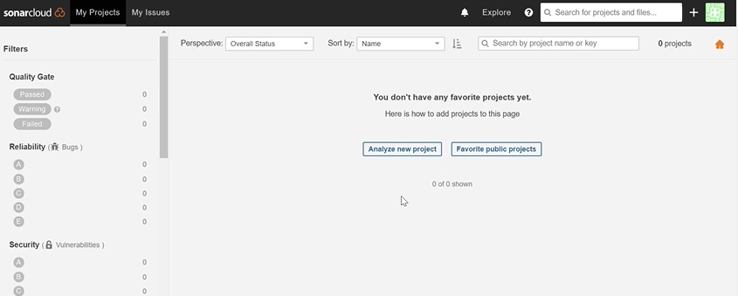

Create a new organization

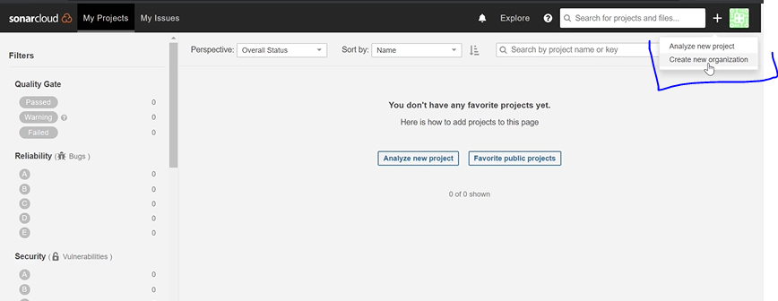

1. Then create an organization and project in SonarCloud.

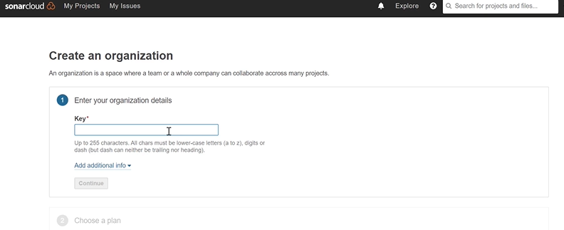

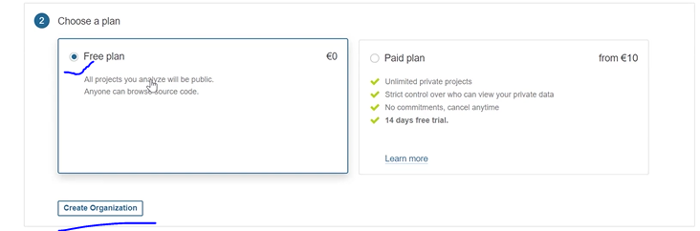

Now Organization has been setup, it’s time for project.

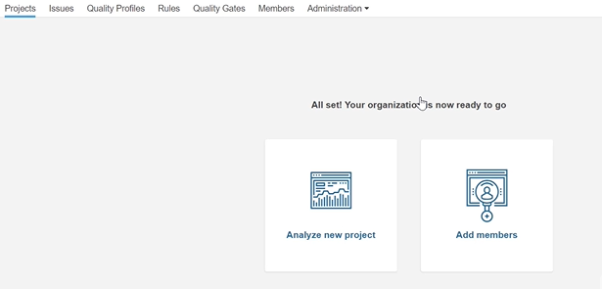

Click on Analyze new project , give project key.

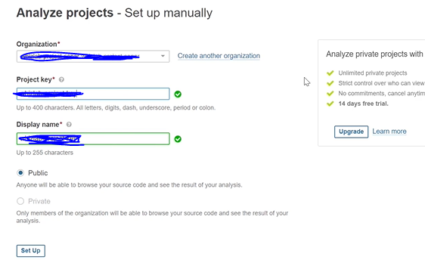

Now project has been setup.

1. Install the SonarCloud extension in Azure DevOps.

Now go to azure devops project and go to organization settings 🡪 Extension -🡪 search in marketplace and search for Sonar Cloud.

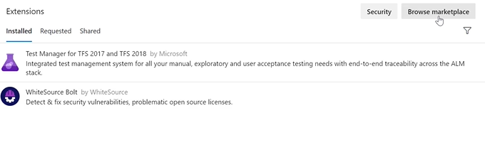

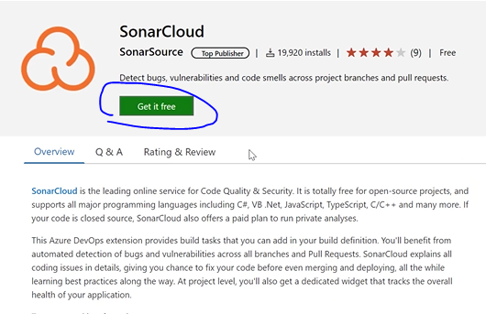

Choose your Devops organization and click on Install.

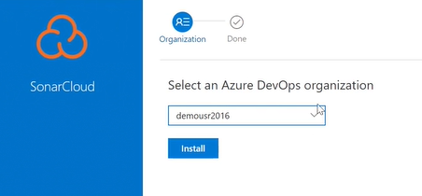

1. **Create a service connection for your Azure DevOps project.**

**After that go to project 🡪 Project settings 🡪 Service Connections**

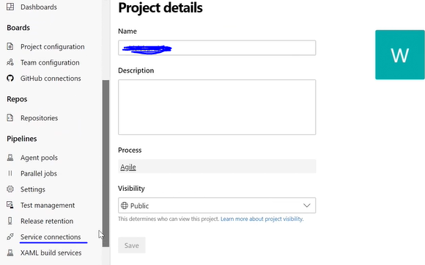

Create a new service connections.

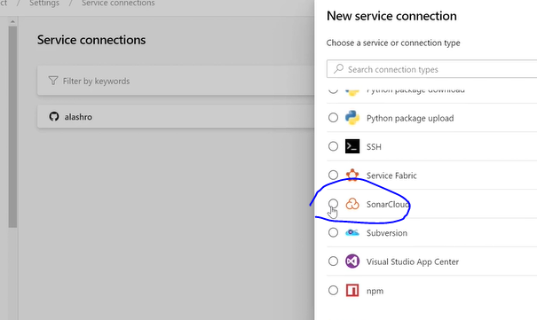

It will ask for some token for authentication purpose.

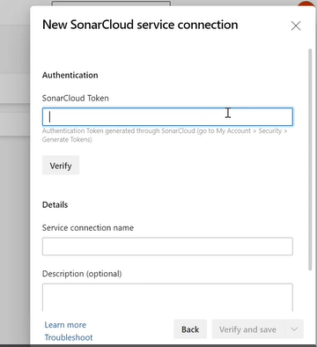

Go to my account and click on Security tab and generate new token. Copy this token and paste into **SoanrCloudToken** option.

Service connection name can be anything , save and verify.

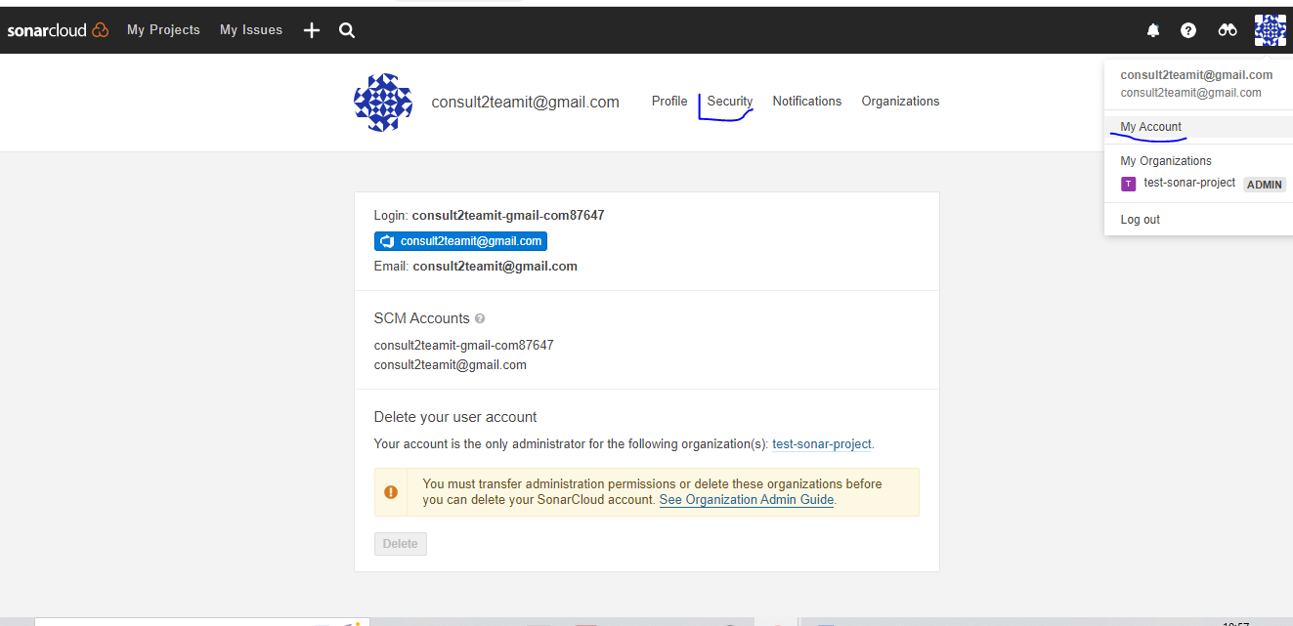

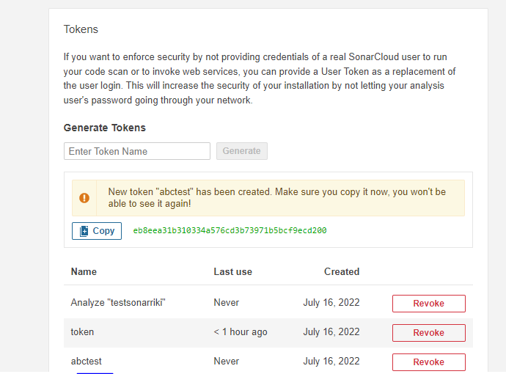

1. Add the steps to your build pipeline for SonarCloud.

Now go to your project and go to pipeline tab and edit pipeline (for example I have taken .Netcore one)

You will see 3 sonar task which are available.

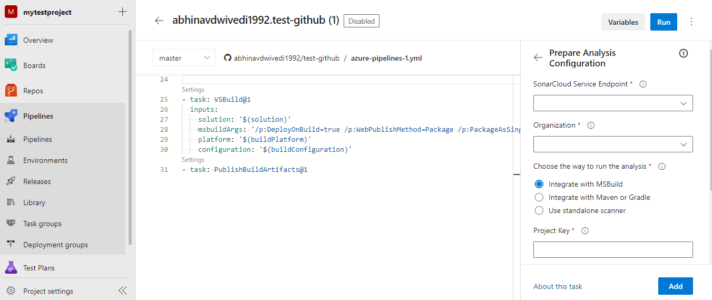

Take this from sonar project.

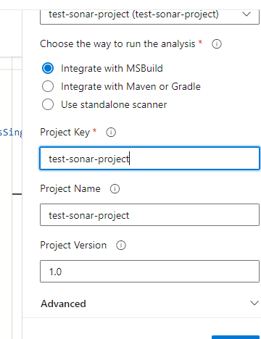

**Add two sonar task**

Prepare Analysis configuration

Run Code Analysis

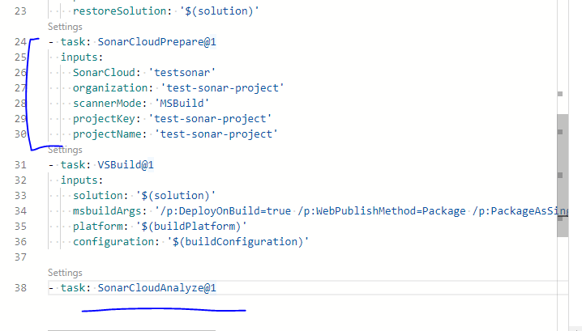

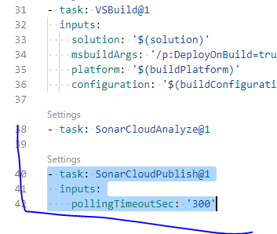

Now save this pipeline and build the same.

Once pipeline gets completed check into Sonar cloud. During the builds process you will see some error messages.

